Serial No:
Sessional Exam-II
Total Time: 1 Hour
Paper attempt : 50 min
Submission : 10 min
Total Marks: 100

CL1002: Programming Fundamentals Lab
Thursday 17th November, 2022
Course Instructors
Muhammad Toqeer, Riva Malik, Sher Bano, Muhammad Usman

_____________________________________________ _____________________
Student Name Roll No. Section Signature

DO NOT OPEN THE QUESTION BOOK OR START UNTIL INSTRUCTED.
This is a Close book Paper, you are not allowed to use Internet or any Gadgets including USB device.
Instructions:
- Attempt all of them. Read the question carefully, understand the question, and then attempt it.
- No additional sheet will be provided for rough work. Use the back of the last page for rough work.
- Calculator sharing is strictly prohibited.
- If found any kind of plagiarism in your code F grade will be awarded.
- Submission will be opened before 10 minutes end of the exam.
- Put your all .cpp files in single folder name it Roll_no_Section_S2(22i_6069_A_S2) and zip that folder and name of the folder is same as mentioned.

 | Q-1 | Q-2 | Total
Marks Obtained
Total  Marks | 50 | 50 | 100

Question 1 [50 Marks]
(Functions and loop, and control structures)

You are given N integers ​a2​,…,aN​. Let's define functions f and g :

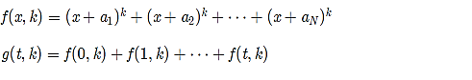

You are also given integers T and K. Calculate g(T , i) for each i between 0 and K inclusive.
For example: -
Input : - a1=1, a2=3, T=4, K=3
Output: -

Print a single line containing K+1 space-separated integers — the values of g(T,0),g(T,1),…,g(T,K).

Output series of the above input is: -
10 40 190 1000
Note: consider only a1 and a2 (where N=2); Must include functions
#include <iostream>
#include <cmath>
using namespace std;
int f(int x, int k, int n1, int n2){
return pow(x+n1, k) + pow(x+n2, k);;
}

int g(int t, int k){
int sum=0;
for(int j=0; j<=t;j++)
sum+=f(j, k, 0,1);
return sum ;
}
int main() {
for(int i=0; i<4;i++){

cout<<g(4,i)<<endl;
}
}

Rubrics for Q1:
1- Complete running Question using 2 functions with complete answers --- 50 marks
2- Complete running Question using 1 functions --- 35 marks
3- Error but using 2 functions and highlighted logic matched --- 30 marks
4- without Functions complete running program --- 20 marks

Question 2 [50 Marks]
(Arrays and loops and control structures)

Hamza found some matches in the kitchen and he immediately started playing with them.
The first thing Hamza wanted to do was to calculate the result of his homework — the sum of A and B and write it using matches. Help Hamza and tell him the number of matches needed to write the result.
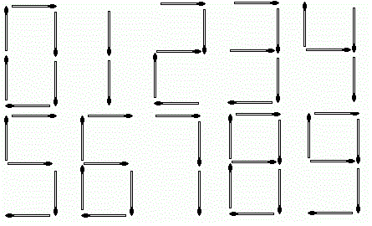

Digits are formed using matches in the following way: -

For example:-
if A =13 and B = 12 -> A+B = 25 then match sticks required are 10.
#include <iostream>
using namespace std;

int main(){
int match_stick[10]={6, 2, 5, 5, 4, 5, 6, 3, 7, 6};
int num1=44, num2=33;
int sum=num1+num2;
int stick_sum=0;
while(sum>0){
//stick_sum+=match_stick[sum%10];
int x=sum%10;
stick_sum+=match_stick[x];
sum/=10;
}
cout<<"Sum of "<<num1<<" and "<<num2<<" is "<<num1+num2<<"\nWhile their stick sum is : "<<stick_sum<<endl;
}

Rubrics for Q2:
1- If complete running question using arrays (matched above logic) ---- 50 marks
2- If errors but used arrays and highlighted logic found --- 25 marks
3- If no arrays are used but complete running code (if else, switch case) – 20 marks
4- Else 0 marks

